CS4563

3/31/2018

Eric Chen

Homework 5b

1. (a) Since the cost is 0, Xi will be outside the soft margin and correctly classified.

(b) Since the cost is between 0 and 1, xi will be between the hyperplane and the margin but will be correctly classified.

(c) Xi is on the wrong side of the margin and misclassified.

1. When c = 0.1

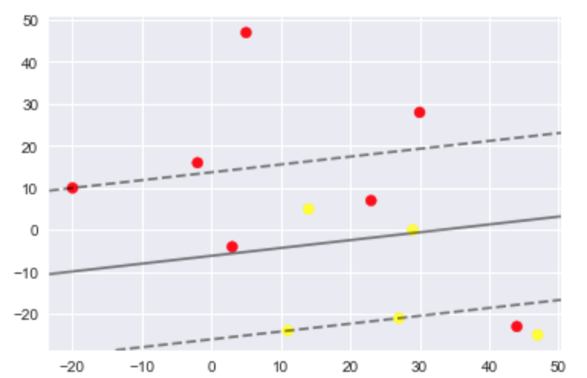

when c = 10

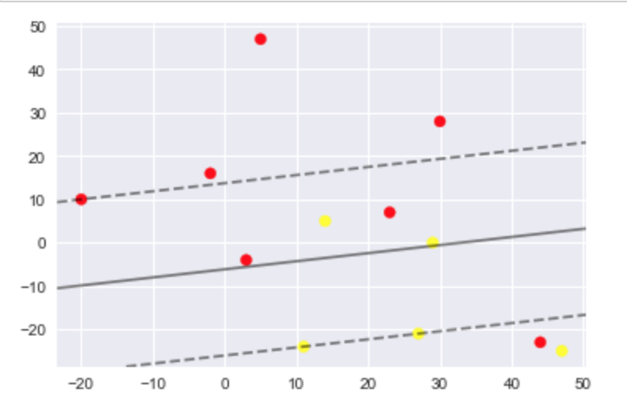

1. (a)

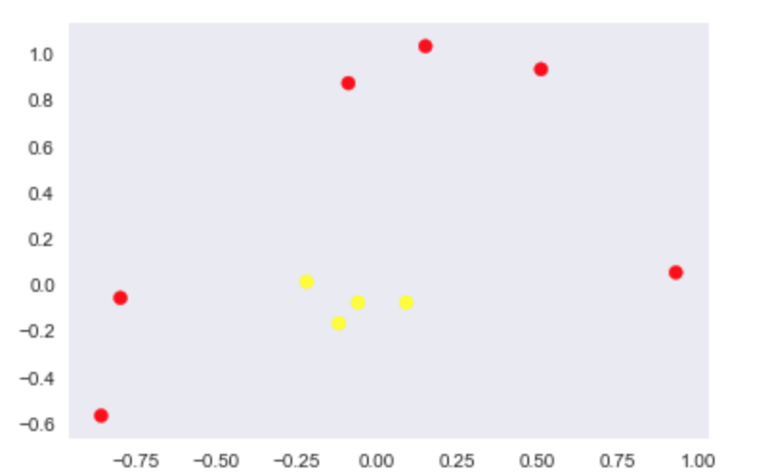

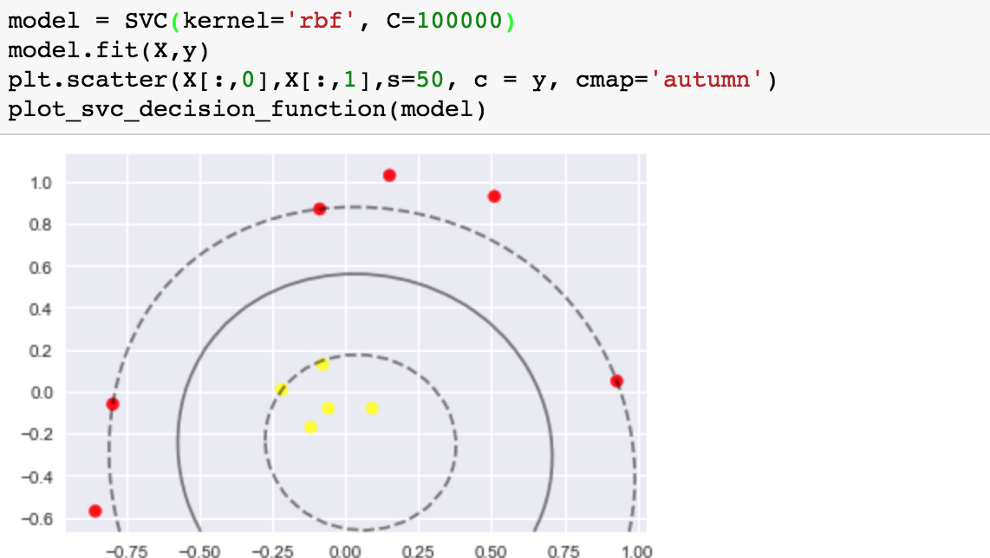

(b)

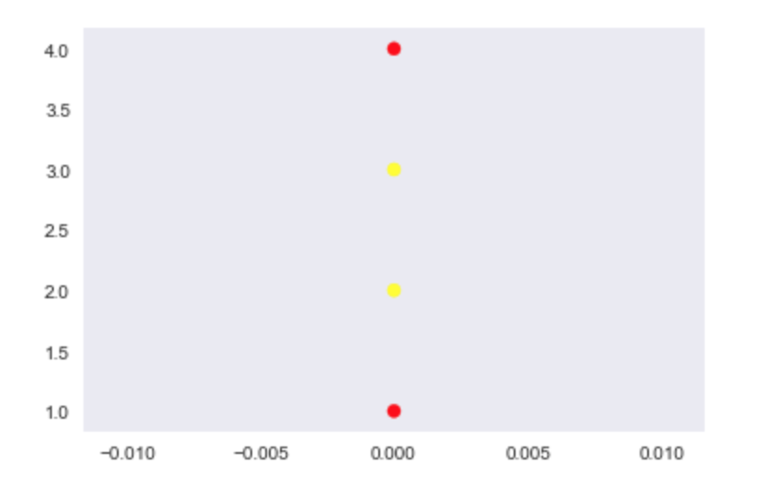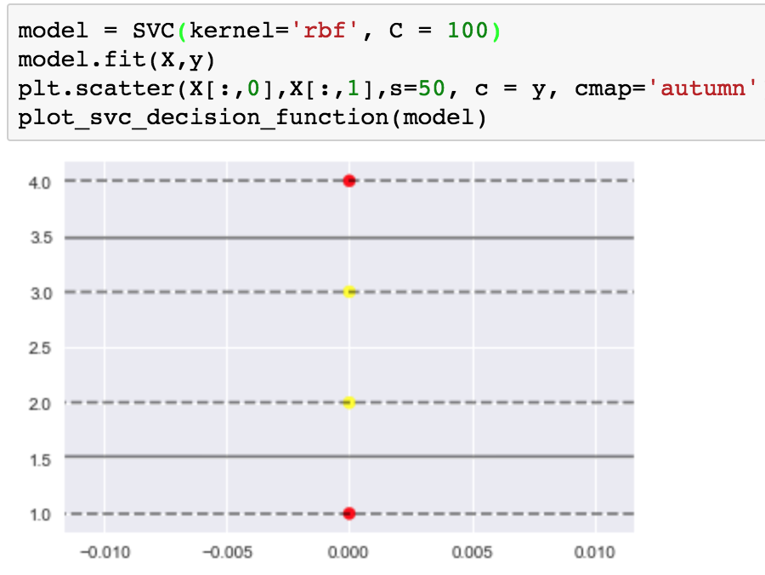

1. It didn’t change because the point removed was not on the margin. If a point on the margin is removed, the margin will be forced to change.